Cargo Claims Write-up

Data Preparation and Cleaning

  - Overview

Prior to modelling, the raw data of cargo claims underwent data cleaning to ensure data consistency and accuracy fit for modelling. The dataset is divided into two sheets, a frequency sheet and a severity sheet, all cleaning steps were implemented using python.

  - Cleaning Procedures

Typos were corrected and column names were normalised to a consistent snake_case format.

The following row-level filters were applied sequentially to remove rows unsuitable for modelling:
- Rows containing placeholder text (e.g. “NA” , “???”) were removed.
- Rows with any missing values were dropped.
- Duplicate records were identified and removed.
- Non-integer values in integer expected fields were dropped.

All numeric values were changed to be expressed in base units. E.g. 100 K $→$ 100,000

All values were possible were validated against the ranges specified in the Encyclopaedia. Rows with values outside such ranges were removed.

Statistical Modelling

2.1 Modelling approach

Parametric distributions were fitted to both the frequency and severity claims data. This approach was adopted because of insufficient information on the current company’s data. Without knowledge of input variables, the multivariate regressions or machines learning models such as decision trees or neural networks were deemed unsuitable.

However, due to this limitation, the respective modelling then assumes data provided is representative of the company’s and solar system data and conditions. Additionally, another assumption in the modelling is that all fitted distributions are independent of one another, frequency is independent of severity and the severity distributions of cargo types are mutually independent.

2.2 Frequency Modelling

The number of claims per shipment was fitted and compared using both Poisson and Negative Binomial distributions. The variance to mean ratio of the observed frequency data was 1.42, confirming overdispersion and indicating that the Poisson distribution is misspecified. The Negative Binomial distribution accommodates for overdispersion via the additional shape parameter. Table 1, confirms the superiority of the Negative Binomial fit:

Table 1 – Comparison of Poisson and Negative Binomial fit for Frequency

Distribution | AIC | Zero-Claim Reproduction
Poisson | 150,034 | 78.29%
Negative Binomial | 143,885 | 81.74% (observed: 81.77%)

The Negative Binomial was selected as the frequency model and its fitted parameters are:

$$Frequency\sim NB(k=1.8632,p=0.5370)$$

A formal statistical assessment was conducted to determine whether each cargo type required its own frequency distribution. Three test were applied:

- Chi-squared test of independence: $p=0.381$ (not significant)
- Kruskal-Wallis test: $p=0.348$ (not significant)
- Poisson log-likelihood ratio test: $p=0.365$ (not significant)

On the basis of these results, each cargo type frequency distribution was not statistically significant enough to be considered different.

2.3 Severity Modelling

Transforming the aggregate claims severity data using a log function exhibits a bimodal distribution, shown in Figure 1, with two distinct visible peaks.

Figure 1 – Log Transformation of Claims Severity Data

Severity was thus modelled separately for each cargo type given the materially difference distribution of cargo claim severities. QQ plots and the Kolmogorov-Smirnov p-value were treated as the primary diagnostic tools for assessing distributional fit given their ability to measure body and tail fits.

Table 2 – Fitted Severity Distributions Summary

Cargo Type | Distribution | KS p-value
Cobalt | Log-Normal | 0.9494
Gold | Log-Skew-Normal | 0.7533
Lithium | Log-Normal | 0.9906
Platinum | Log-Skew-Normal | 0.8736
Rare Earths | Log-Skew-Normal | 0.2714
Supplies | Log-Exponentiated Weibull | 0.0913
Titanium | Log-Exponentiated Weibull | 0.3860

(Consider the below table and graph to be in the appendix)

Table X1 – Severity Distribution Parameters

Table X2 – Severity Distribution Confidence Intervals of Parameters

Figure 2 – QQ plot of all Fitted Severity Distributions

Expected Losses and Premium Pricing

3.1 Insured Portfolio Characterisation

The insured company, Cosmic Quarry, operates mining facilities across three solar systems with the following annual production volumes, shown in Table 3

Table 3 – Mine Product

Cluster / System | Number of Mines | Annual Production (thousand tons)
Helionis Cluster | 30 | 375
Bayesia System | 15 | 250
Oryn Delta | 10 | 125
Total | 55 | 750

The given data does not specify a mine-level ore composition. Thus, it was assumed that the ore distribution observed in the given historical claims dataset is representative of the average produce mix across all insured operation during the relevant underwriting period. This allows the cargo data to serve as a proxy for the production distribution. The distribution of cargo types and the annual production tonnage is shown in Table 4. Additional, the amount of supplies is assumed to be proportionate to the total tonnage of ore produce (15.30%)

Table 4 – Distribution and Annual Production of cargo types

Cargo Type | Share by Weight | Annual Tonnage
Titanium | 38.18% | 286,350
Cobalt | 30.40% | 228,000
Lithium | 22.57% | 169,275
Rare Earths | 7.62% | 57,150
Gold | 0.77% | 5,775
Platinum | 0.46% | 3,450
Supplies |  | 114,753

Per-kilogram estimates of cargo prices were estimated, shown in Table 5 from the claims dataset by computing the dividing the cargo value by weight. Approximately 30 outlier data points were excluded likely reflecting data entry error or exceptional circumstance.

Table 5 – Cargo Prices per Kilo

Cargo Type | Estimated Price (per kg)
Titanium | $7
Supplies | $10
Cobalt | $52
Lithium | $82
Rare Earths | $85
Gold | $54,500
Platinum | $135,600

The number of annual shipments per cargo type was estimated by dividing each cargo type’s annual tonnage by the mean shipment weight observed in the dataset, shown in Table 6:

Table 6 - Estimated Shipments per Year

Cargo Type | Annual Tonnage | Mean Shipment Weight (kg) | Est. Shipments/Year
Titanium | 286,350 | 187,469.52 | 1,527
Cobalt | 228,000 | 150,007.17 | 1,520
Lithium | 169,275 | 112,027.95 | 1,511
Rare Earths | 57,150 | 37,688.51 | 1,516
Gold | 5,775 | 3,810.13 | 1,516
Platinum | 3,450 | 2,285.99 | 1,509
Supplies | 114,753 | 75,189.57 | 1,526

3.2 Monte Carlo Loss Simulation

Expected losses and the standard deviation of losses were estimated using Monte Carlo simulation using 100,000 paths. For each path, the total loss using Equation 1:

$$L=\sum_{Cargo Type}{\sum_{s=1}^{Number of Shipments}{\sum_{j=1}^{N_{c,s}}{X_{c,s,j}}}}$$ | (1)

$N_{c,s}$ is the number of claims on shipment s of cargo c
$X_{c,s,j}$ is the severity of claim j

Expected loss and standard deviation is then calculate using Equation 2 and 3

$$E\left[L\right]=\frac{1}{M}\sum_{m=1}^{M}{L_{m}}$$ | (2)
$$SD\left(L\right)=\sqrt{\frac{∑{\left(L_{M}-E\left[L\right]\right)}^{2}}{N-1}}$$ | (3)

3.3 Premium Pricing Formula

Gross premiums are calculated using the following Equation 4:

$$Premium=(1+Profit Margin)(E\left[L\right]+Risk Loading×SD\left(L\right)+Expense Loading×E[L]$$ | (4)
The components of the pricing formula are:
- $E[L]$: Expected loss
- $SD(L)$: Standard Deviation
- Risk Loading is a variable used to ensure the premium can cover costs
- Expense Loading is the expected costs, including underwriting, claims processing and operation costs
- Profit Margin is applied to total expenses to yield the gross written premium

3.4 Production Growth Assumptions

The Encyclopaedia states that the Cosmic Quarry intends to expand production by 25% in the Helionis Cluster and Bayesia System and by 15% in the Oryn Delta over the next 10 years. It is assumed that these growth rates are compounding and continuous, yielding the following annual compound growth rates:
- Helionis Cluster and Bayesia System: 2.26% per annum
- Oryn Delta: 1.41% per annum
For the multi simulation of losses, the following stochastic factors are incorporated
- Metal prices are modelled to have log-normal returns, where expected growth equal to inflation and standard deviation estimated from historical commodity price data.
- Production growth rates are modelled to be normally distributed where standard deviation is set to be 25% of expected growth rate.
- Inflation and interest rates are modelled to be normally distributed with parameter estimated through the given data.

3.5 Projected Gross Premiums

Premiums are projected over the next 10-year period, derived from a Monte Carlo simulation incorporating the stochastic production growth, metal price dynamics and inflation. Table 7 presents each year’s premium.

Table 7 – 10 Year Premiums

Year | Gross Premium ($)
1 | 28,803,689,769
2 | 30,204,456,245
3 | 31,597,653,232
4 | 33,138,122,011
5 | 34,709,866,598
6 | 36,287,948,911
7 | 37,972,956,328
8 | 39,791,620,339
9 | 41,685,381,603
10 | 43,633,666,212

Reserves and Stress Testing

4.1 Reserves Setting Methodology

Reserves are set such that the probability of ruin in any individual policy year does not exceed 1% under the base case scenario, defined as the scenario in which the claims modelling is assumed to be correctly specified.

The probability of ruin in a given year is defined as

$$\operatorname{Pr}\left(Ruin\right)=\frac{Number of paths where reserves fall below zero}{Total number of paths}$$

The reserve calculation of each path follows a specific cash flow structure across each simulated path. At $t=0$ the initial reserve is set. At the beginning of each year, the full year’s premium is collected, then the loss for that year is then simulated by drawing from the fitted frequency and severity distributions and expenses are subtracted. This process repeats for each of the 10 policy years.

Reserves dynamics between years are governed by the following rules:
- All annual profits (premiums collected less losses and expenses) are retained and added to the reserve at year end.
- Reserves earn investment income at the prevailing 10 year risk free interest rate which is modelled stochastically

The minimum initial reserve required to ensure that the annual probability of ruin does not exceed 1% in any give year, based on 10,000 simulation path is shown in Table 8

Table 8 – Reserves Summary

Metric | Value
Required Initial Reserve | $17,419,921,875
Worst-Year Annual Ruin Probability (at this reserve) | 1.00%
Expected End-of-Year-10 Reserve | $50,819,617,106
Total Expected Profit Over 10 Years | $33,399,695,231

4.2 Annual Reserve and Profitability Projections

Table 9 presents the year-by-year reserve adequacy, profitability metrics and ruin probabilities under the base case simulation.

Table 9 – Annual Reserve and Profitability Projections

Year | Expected Loss ($) | Annual Profit ($) | Investment Income ($) | End-of-Year Reserve ($) | Ruin Prob. (Year)
1 | 21,071,754,905 | 2,500,025,851 | 504,504,547 | 19,919,947,726 | 0.08%
2 | 22,098,609,870 | 2,634,835,556 | 576,492,780 | 22,554,783,282 | 0.21%
3 | 23,116,497,482 | 2,781,186,266 | 652,924,153 | 25,335,969,548 | 0.42%
4 | 24,249,859,826 | 2,976,544,039 | 733,754,444 | 28,312,513,587 | 0.54%
5 | 25,394,749,663 | 3,195,841,051 | 819,458,625 | 31,508,354,638 | 0.79%
6 | 26,552,466,909 | 3,393,758,511 | 911,882,155 | 34,902,113,148 | 0.88%
7 | 27,789,771,372 | 3,655,906,778 | 1,011,478,322 | 38,558,019,927 | 1.00%
8 | 29,122,011,421 | 3,841,758,525 | 1,116,909,723 | 42,399,778,451 | 0.91%
9 | 30,504,768,995 | 4,125,307,538 | 1,226,965,839 | 46,525,085,989 | 0.90%
10 | 31,934,515,406 | 4,294,531,117 | 1,348,280,951 | 50,819,617,106 | 0.88%

4.3 Stress Testing

To assess the sensitivity of the reserve and premium structure, five stress scenarios were constructed using different standard errors for each distribution. Stress scenarios were then defined by shifting all severity distribution parameters simultaneously to correspond to specified percentiles of error. This produces scenario representing moderate and extreme adverse and favourable deviations from the base case. The five scenarios and their implied mean per cargo type are shown in Table 10.

Table 10 – Mean Value of Different Scenarios

Cargo Type | Base Mean ($) | P25 Mean ($) | P75 Mean ($) | Best (P2.5) ($) | Worst (P97.5) ($)
Cobalt | 679,144 | 670,336 | 689,258 | 651,511 | 710,119
Gold | 42,233,844 | 37,556,180 | 47,741,055 | 27,315,003 | 74,992,000
Lithium | 818,529 | 805,767 | 831,940 | 785,196 | 857,771
Platinum | 10,293,270 | 8,972,915 | 11,947,840 | 4,148,965 | 30,268,491
Rare Earths | 287,951 | 266,671 | 310,521 | 229,450 | 358,088
Supplies | 88,093 | 83,019 | 93,446 | 62,257 | 237,494
Titanium | 131,002 | 122,424 | 139,704 | 105,253 | 175,290

The P25 and P75 scenarios represent moderate parameter shifts reflecting plausible near term uncertaintity in fitted parameters. The best and worst scenarios use the 2.5th and 97.5 percentiles respectively, representing the tails of the parameter distribution. In all stress test runs, the initial reserve is held fixed at $17,419,921,875 and premiums remain at the based price levels, isolating the impact of distribution uncertainty.
4.4 Stress Test Results Summary

Table 11 –

Scenario | Max Annual Ruin Prob. | Total 10-Year Profit ($) | End-Yr-10 Reserve ($) | Passes 1% Test?
Base Severity | 0.93% | 33,134,593,258 | 50,554,515,133 | Yes
P25 Severity | 0.02% | 65,864,700,077 | 83,284,621,952 | Yes
P75 Severity | 29.83% | -5,880,117,193 | 11,539,804,682 | No
Best Severity | 0.00% | 148,050,209,585 | 165,470,131,460 | Yes
Worst Severity | 100.00% | -254,143,525,945 | -236,723,604,070 | No

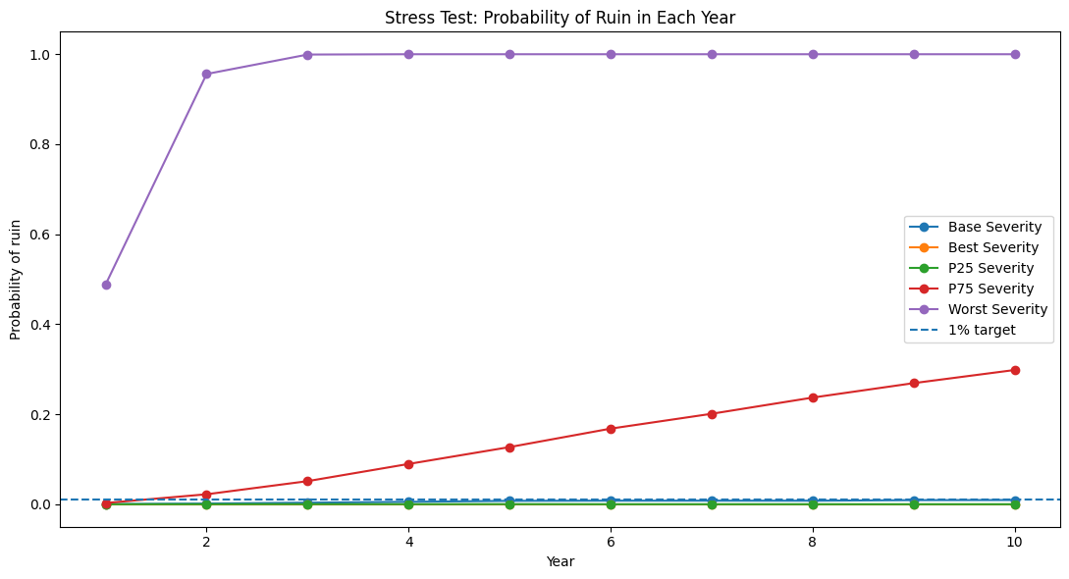

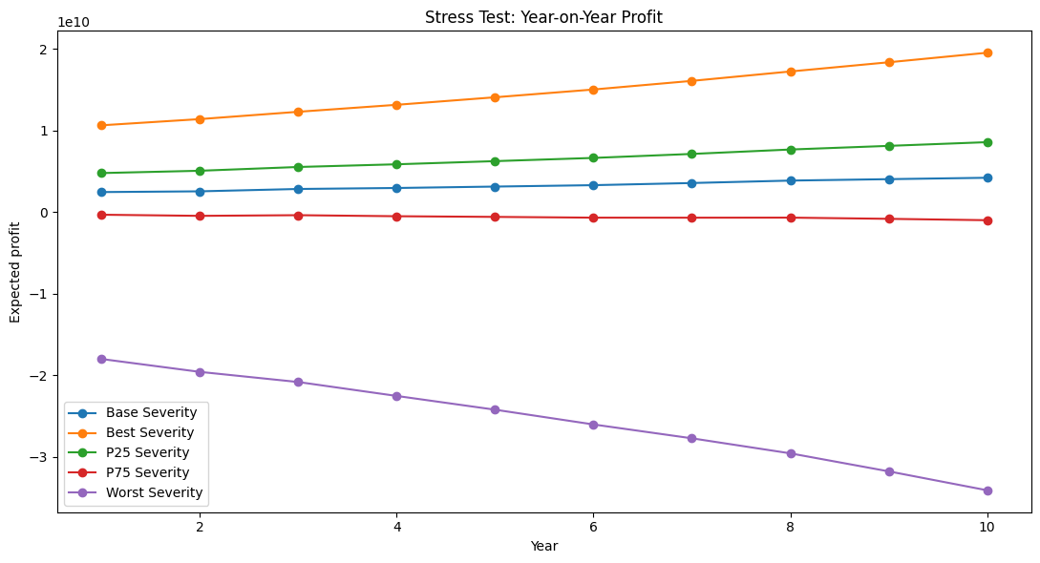

4.5 Interpretation

Base case: The reserve satisfies the 1% annual ruin constraint in all years, generating approximately $33.1 billion in total profit over the policy period, with the end-of-year-10 reserve growing to $50.6 billion.

P25 scenario (moderate favourable): A downward shift of severity parameters to the 25th percentile bootstrap bound reduces the maximum annual ruin probability to near zero (0.02%) and lifts total expected profit to approximately $65.9 billion, reflecting the disproportionate impact of even moderate parameter improvements given the fat-tailed distributions.

P75 scenario (moderate adverse): A shift to the 75th percentile is sufficient to breach the 1% annual ruin constraint, with the ruin probability reaching 29.8% by Year 10 and cumulative 10-year profitability turning negative at −$5.9 billion. This indicates the reserve has limited tolerance for even moderate adverse parameter misspecification.

Best case (P2.5): No instances of ruin across any simulated path; total expected profit of approximately $148.1 billion over 10 years.

Worst case (P97.5): Near-immediate ruin — 48.8% annual ruin probability in Year 1, reaching 100% by Year 4 — driven primarily by the extreme sensitivity to gold and platinum, where worst-case mean severities are 1.8x and 2.9x the base case respectively. Cumulative losses reach approximately $254 billion.

Overall, the results highlight a material asymmetry in tail risk: the reserve is adequate under correctly specified parameters but highly vulnerable to adverse distributional misspecification, underscoring the need for reinsurance cover on the high-value, fat-tailed cargo types.

